**A: Application Checklist**

|  |  |  |  |
| --- | --- | --- | --- |
| Name |  | Registration No. | 0000-0000 |

**Positions to apply** (Multiple positions up to 5 are applicable.)

|  |  |  |
| --- | --- | --- |
| Priority | Entry ID | Notes |
| 1 |  | 1. Entry IDs in the left boxes should be identical to ones listed in the confirmation e-mail of your advance registration. 2. We ask you to complete advance registration again if you wish to change priorities to apply. We simply ignore your previous registration. |
| 2 |  |
| 3 |  |
| 4 |  |
| 5 |  |

**Contents of Application Document**

Please fill in the box of “**The number you attached**”. For Form E and I, please fill in the number of documents you attached. For other Forms, please place “1”.

|  |  |  |  |  |
| --- | --- | --- | --- | --- |
| **Form** | **Documents** | **Notes** | **Necessary Number** | **The number you attached** |
| **A** | Application checklist | (a)Please fill in "Registration Number" found in the e-mail for confirming advance registration sent from AIST.  (b)An application document without “Registration No.” is not acceptable. | 1 |  |
| **B** | CV (Curriculum Vitae) | (a)Information in this format should be identical to ones in an advance registration.  (b)The "SIGNATURE" field must be filled out in handwriting. | 1 |  |
| **C** | List of publication and other achievements | (a)Please do not change categorization and file format. | 1 |  |
| **D** | Summary of Ph. D. thesis | (a)No more than 1-page, including figures.  (b)For applicants who are scheduled to earn Ph. D. degree, summary of current research activities for Ph. D. degree should be submitted. | 1 |  |
| **E** | Reprints of publications | (a)Up to 3 publications are acceptable for evaluations.  (b)Please confirm that the electronic files are not protected by password. Scanning a printed copy of protected reprints is recommended.  (c)The drafts before publication (including preprint) cannot be accepted. | Up to 3 |  |
| **F** | Summary of the publication (E) | (a)Please select one of the publications attached in Form E and prepare an abstract of your publication.No more than 1-page, including figures.  (b)Please place title of the publication, name of author(s), journal and publication year, volume and pages. | 1 |  |
| **G** | Career summary | (a)Please describe career highlights and core competence as a research scientist.  (b)No more than 1-page, including figures. | 1 |  |
| **H** | Reason for applying and Future research plan in AIST | (a)Please describe reason for applying and your research plan in AIST, including short-term outcome (within about 5 years) and future direction and career planning for about 15 to 20 years.  (b)No more than 1-page, including figures. | 1 |  |
| **I** | Recommendation letter | (a)At least 1 recommendation letter should be submitted.  (b)The letter must be signed by a recommender.  (c)The addressee’s name in the letter should be “President of AIST Kazuhiko Ishimura”.  (d)The recommender should list the name of the nominee.  (e)The issued date should be April 2, 2025 or later.  (f)An AIST employee is not eligible to be a recommender.  (g)Recommendation letter(s) should be submitted in PDF by being attached in application document or sent by email to AIST directly from the recommender.  (h)Please fill in the right box such as “number of letter(s) you attached in application document / gross number of letter(s) to be submitted”. | 1 or more | / |
| **J** | Declaration Concerning the applicability of “Specific Categories” | (a)Please review the request letter [[PDF](https://www.aist.go.jp/Portals/0/resource_images/aist_j/humanres/02kenkyu/temp/Explanatory%20Material%20for%20Export%20Control%20Form%202%20(applicants%20for%20new%20employment).pdf)] and attach a scanned copy of the signed original to your application.  (b)All pages of the form should be submitted. | 1 |  |
| **K** | GDPR Consent Form  **\* Only applicable person** | (a)EEA (European Economic Area) residents are requested to submit a consent form following GDPR.  (b)Please attach a copy of it to your application documents.  (c)EU citizens living outside EEA are not required to submit this form. | 1 |  |
| **L** | Research plan for positions of “Outstanding Research Scientist”  **\* Only applicable person** | (a)Please describe your research theme and research plan as “Outstanding Research Scientist” in AIST within 5 years. **No more than 2-pages,** including figures.  (b)Please specify the Research Department which is related to your research theme. | 1 |  |

* Application document should be produced as a single PDF file and bind all the Forms from A to J in an alphabetical order.
* Name of the file name should be “(Registration Number) - (Name).pdf,” such as “0999-0999-Sansou Tarou.pdf”.
* File size should be less than 20 MB, and downsizing is necessary for uploading.
* **Applications that do not follow the instructions above are not acceptable.**

**B: CV (Curriculum Vitae)**

|  |  |  |  |  |  |  |  |  |  |  |
| --- | --- | --- | --- | --- | --- | --- | --- | --- | --- | --- |
| Name in full | FAMILY | First | | | Middle | | Sex |  | | Attach your photo here. |
|  |  | | |  | |
| Date of Birth  (dd/MM/yyyy) | / /  (Age:　　　) | | | Nationality | |  | | | |
| Mailing address | (Home) | | | | | | | | |
| (Phone) | | | | | | | | |
| (Office) | | | | | | | | |
| (Phone) | | | | | | | | |
| Email |  | | | | | | | | | |
| Academic Background (major, name of school) / From high school to latest education |  | | | | | | | | From (Month/Year)  To (Month/Year) | |
|  | | | | | | | | From (Month/Year)  To (Month/Year) | |
|  | | | | | | | | From (Month/Year)  To (Month/Year) | |
|  | | | | | | | | From (Month/Year)  To (Month/Year) | |
|  | | | | | | | | From (Month/Year)  To (Month/Year) | |
| MSc Degree | Title of Master thesis | | |  | | | | | | |
| Date obtained (Month/Year) | | |  | | | | | | |
| Major, Name of school | | |  | | | | | | |
| Name of Supervisor | | |  | | | | | | |
| PhD Degree | Title of doctoral thesis | | |  | | | | | | |
| Degree | | | PhD in | | | | | | |
| Date obtained (Month/Year) | | |  | | | | | | |
| Major, Name of school | | |  | | | | | | |
| Name of Supervisor | | |  | | | | | | |
| Previous employment | From(Month/Year) | | To(Month/Year) | Institution / Position | | | | | | |
|  | |  |  | | | | | | |
|  | |  |  | | | | | | |
|  | |  |  | | | | | | |
|  | |  |  | | | | | | |
|  | |  |  | | | | | | |
|  | |  |  | | | | | | |
|  | |  |  | | | | | | |
| * If you have worked at AIST, please provide the name of your research unit.  (e.g.) AIST Postdoctoral researcher (XX Research Institute)  JSPS Research Fellow (AIST XX Research Center)  * If the term of office has been established for the incumbent, please indicate the expected term of office to be completed. | | | | | | | | | |
| Subsidiary Job  (independent business or side business) | *Please check whether you engage in subsidiary job regardless of whether it is paying job or not. (e.g. Visiting Professor, Technical advisor)  *If you join AIST and wish to engage in subsidiary job, independent business or side business, you must obtain permission from AIST in advance. | | | | | | | | | |
| □ I engage in subsidiary job and wish to continue it after joining AIST.  □ I engage in subsidiary job and will not continue it after joining AIST.  □ I don’t engage in subsidiary job. | | | | | | | | | |

|  |  |  |  |  |  |  |  |
| --- | --- | --- | --- | --- | --- | --- | --- |
| Time-gap after graduating from high school | From(Month/Year) | To(Month/Year) | Activities | | | | |
|  |  |  | | | | |
|  |  |  | | | | |
| *If there is any time-gap from after graduating high school to present, please fill in above field.  (e.g.) April 2001 - March 2002 Prepare for study abroad  May 2010 - September 2004 Job Hunting | | | | | | |
| Qualifications |  | | | Experience in abroad (work or study): | Country:  Affiliation:  Period of Residence (From Month/Year To Month/Year):  Purpose: | | |
| Hobby |  | | |
| Condition of your health |  | | |
| Marital status  *Answering this item is optional | □ Married  □ Unmarried | | | Family  *Answering this item is optional |  | |
| Language ability | Japanese : Grade your language ability  English : Grade your language ability  Other languages: Grade your language ability | | | | |
| Notes |  | | | | |

**【Application Confirmation】**

1. I declare that the information given in this application is true and accurate to the best of my knowledge and belief, and I understand that in the event of my information being found false or incorrect at any stage, my employment shall be liable to cancellation.
2. I declare that none of the following conditions apply to me.

- a person who has been subject to disciplinary action in my current or former employer(s); and

- My eligibility to apply for and participate in competitive research grants is not restricted.

1. I agree that AIST make a contact to my current or former employer(s) regarding the following matters and answers from 　 my current or former employer(s);

- employment record (duty, reason for resignation, reward and punishment record, health conditions, and etc.)

DATE (MM/DD/YYYY): ／ ／

SIGNATURE

**C: List of Publications and other Achievement**

|  |
| --- |
| <Notes>  *Please do not change categorization and file format.  *Please fill “N/A” in category for which there are not applicable publications or achievements.  * Figures cannot be used.  (e.g.)  7. Patents  ① [Patent Applications]  N/A |

Researcher ID:

|  |  |
| --- | --- |
| ORCID ID (https://orcid.org/) |  |
| Researcher ID (https://www.researcherid.com/) |  |

* If you have an ID (or IDs) of these databases, please enter the ID number.

**1. Original Papers**

|  |
| --- |
| <Notes>  * Papers already published or in press should only be listed. Papers submitted but under review to be published or papers accepted but before publication should be listed in the ⑥.  * Please indicate number of pages of peer-reviewed papers and conference proceedings listed in Item 1.  * Please indicate degree of your contributions to each paper listed in Item 1 in percentage after your authorship name.  *DOI can be indicated.  (e.g.)  1. Original Papers  　① [Peer-Reviewed Journals, First Author]  1) “Encouragement of Researchers in the AIST”, Taro Sanso (80%) and Jiro Tsukuba, International Journal of Human Resources in Research Institutes, vol.20, pp.10-20, January 2011, DOI:・・・・・・・.  2) “A Note on Personnel Management in an Independent Administrative Organization”, Taro Sanso (50%) and Jiro Tsukuba, Japanese Journal of Research Environment (in press), about 10 pages |

　① [Peer-Reviewed Journals, First Author]

1)

2)

3)

② [Peer Reviewed Journals, Non-First Author]

1)

2)

3)

③ [Peer Reviewed Conference Proceedings, First Author]

1)

2)

3)

④ [Peer Reviewed Conference Proceedings, Non-First Author]

1)

2)

3)

⑤ [Other Publications without Peer Review System]

1)

2)

3)

⑥ [Papers submitted but under review to be published or papers accepted but before publication]

1)

2)

3)

**2. Review Articles**

|  |
| --- |
| <Note>  * Papers already published or in press should only be listed. Papers submitted but under review to be published or papers accepted but before publication should be listed in the ⑤. |

① [Peer-Reviewed, First Author]

1)

2)

3)

② [Peer Reviewed, Non-First Author]

1)

2)

3)

③ [Non-Peer-Reviewed, First Author]

1)

2)

3)

④ [Non-Peer-Reviewed, Non-First Author]

1)

2)

3)

⑤ [Papers submitted but under review to be published or papers accepted but before publication]

1)

2)

3)

**3. Books or Investigation Reports**

1)

2)

3)

**4. Invited Talks**

① [Academic Conferences]

1)

2)

3)

② [Other Conferences]

1)

2)

3)

**5. Oral or Poster Presentations (First Author or Presenter)**

1)

2)

3)

**6. Awards or Prizes**

1)

2)

3)

**7. Patents**

|  |
| --- |
| <Note>  * Please indicate your ownership ratio of each industrial property in percentage after your name.  **(e.g.)**  **7. Patents**  ① [Patent Applications]  1)“Short-term and Long-term Research Evaluation Systems”, Taro Sanso（50％） and Jiro Tsukuba, 13/99999999 (USA), 15 June 2013. |

① [Patent Applications]

1)

2)

3)

② [Patents Granted]

1)

2)

3)

**8. Research Funds and Scholarships**

|  |
| --- |
| <Note>  *Please indicate sponsor, amount of grant or funds, and granted period.  (e.g.)  8. Research Funds and Scholarships  1) “Recent Trend on Personnel Management in Research Institutes”, KAKENHI, Japan Society for the Promotion of Science, 8,000,000yen, September 2011-March 2012. |

1)

2)

3)

**9. Work experiences at corporation**

|  |
| --- |
| <Note>  *If you have work experiences at corporation, please indicate business experience.  (e.g.)  9. Work experiences at corporation  1) April 2001-March 2012. ABCD Inc. Project Manager  - Made the project a success as a project manager  2) September 2015-July 2018. AIST Co., Ltd.  - Worked at oversea branches and improve business by fiding new customers and making sales |

**10. Achievements to appeal**

|  |
| --- |
| <Note>  *Please indicate achievement to appeal simply.  (e.g.)  10. Achievements to appeal  1) Achieved the high efficiency working hour reduction  2)Started a business when I was in college (September 2012) |

1)

2)

3)

**D: Summary of Ph. D. Thesis**

**(No more than 1 page, including figures)**

**Title:**

**Name:**

**E: Publication (1)**

* Please insert a copy or a PDF file of your paper as "E".

* Papers that have already been published are only acceptable. Note that the drafts before publication (including preprint) cannot be accepted.

**E: Publication (2)**

* Please insert a copy or a PDF file of your paper as "E".

* Papers that have already been published are only acceptable. Note that the drafts before publication (including preprint) cannot be accepted.

**E: Publication (3)**

* Please insert a copy or a PDF file of your paper as "E".

* Papers that have already been published are only acceptable. Note that the drafts before publication (including preprint) cannot be accepted.

**F: Summaries of the publication**

**(No more than 1 page, including figures)**

* Please select one of the publications attached in Form E and prepare an abstract of your publication.

**Title:**

**Authors:**

**Journal and Volume:**

**G: Career summary**

**(No more than 1 page, including figures)**

**Name:**

**H: Reason for applying and Future research plan in AIST**

**(No more than 1 page, including figures)**

**Name:**

**I: Recommendation letter**

* If a copy of the recommendation letter is available, please insert it as “I”. If the recommender is sending the letter directly to the Secretariat of Recruitment and Employment Committee via email attachment, please delete this page.

**J: Declaration Concerning the applicability of “Specific Categories”**

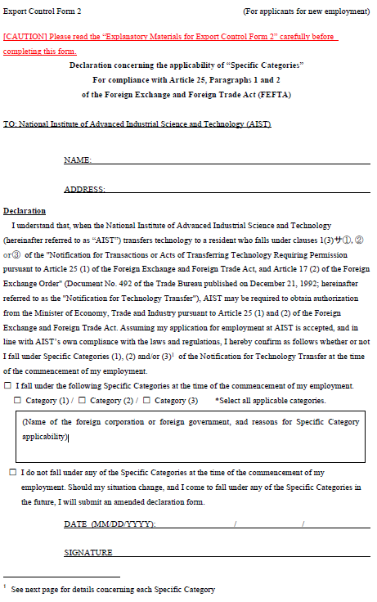

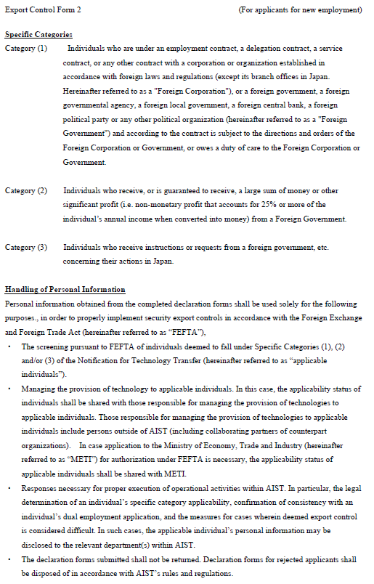

**L: Research Plan for positions of “Outstanding Research Scientist”**

**(No more than 2 pages, including figures)**

* Only applicable person. Delete this page, if not applicable.

**Name:**

**Research theme:**

**Research Department which is related to your research theme:**

**Research Plan in AIST:**

1. **Purpose of research, research background, creativity, novelty**
2. **Research plan including research method**
3. **Research budget Plan of JPY 40,000k, including equipment and facility you need**