A: Application Checklist
Name: |  | Registration No. | 0000-0000
* An application document without “Registration No.” is not acceptable.
Advance registration is compulsory for all applicants of AIST Open Recruitment. Any application without advanced registration is not acceptable, and not to be forwarded for further evaluations. Registration number found in the e-mail for confirming your advance registration from AIST should be given the above box.

Contents of Application Document
- Please check again the notes on the next page before application.
- Please fill in the box of “The number you attached”.
- for Form E and I: please fill in the number of documents you actually attached.
- for other Forms: please place “1”.
Form | Documents | Necessary Number | The number you attached
A | Application checklist | 1
B | CV (Curriculum Vitae) | 1
C | List of publication and other achievements | 1
D | Summary of Ph. D. thesis | 1
E | Reprints of publications | Up to 3
F | Summary of the publication (E) | 1
G | Career summary | 1
H | Future research plan in AIST | 1
I | Recommendation letter | 1 or more  * Recommendation letter(s) can also be sent directly to the Personnel Office of AIST by e-mail from recommender(s). In this case, the copy of letter(s) should not be attached in this application document.  * Please fill in the right box such as “number of letter(s) you attached in application document / gross number of letter(s) to be submitted”. | /
J | Declaration Concerning the applicability of “Specific Categories” | 1
K | GDPR Consent Form  * Only applicable person | 1
L | Research plan for positions of “Outstanding Research Scientist”  * Only applicable person | 1

* Please check the right box if you confirm the condition exactly.
Application document should be produced as a single PDF file and bind all the Forms from A to J in an alphabetical order. Also, file name should be “(Registration Number) - (Name).pdf,” such as “0999-0999-Sansou Tarou.pdf.”
File size should be less than 20 MB, and downsizing is necessary for uploading.
* Applications that do not follow the instructions on this box or on the next page are not acceptable.

Positions to apply: Multiple positions up to 5 are applicable.
Priority | Entry ID | Notes
1 |  | - Entry IDs in the left boxes should be identical to ones listed in the confirmation e-mail of your advance registration.  - We ask you to complete advance registration again if you wish to change priorities to apply. We simply ignore your previous registration.
2
3
4
5
* Do not need to delete this page at the time of application.
Notes on Application Documents
* Forms A through J must be completed. Please prepare additional Forms K and L only if applicable person.
Form | Documents | Notes
A | Application checklist | - Please fill in "Registration Number" found in the e-mail for confirming advance registration sent from AIST.  - Entry IDs should be identical ones and in the same priority order as described in the confirmation email.
B | CV (Curriculum Vitae) | - Information in this format should be identical to ones in an advance registration .  - The "SIGNATURE" field must be filled out in handwriting.
C | List of publication and other achievements | - Please do not change categorization and file format.  - Where examples are shown, please delete the examples and prepare the form.
D | Summary of Ph. D. thesis | - No more than 1-page, including figures.  - For applicants who are scheduled to earn Ph. D. degree, summary of current research activities for Ph. D. degree can be submitted.
E | Reprints of publications | - Up to 3 publications are acceptable for evaluations. The drafts before publication cannot be accepted.  - Please confirm that the electronic files are not protected by password. Scanning a printed copy of protected reprints is recommended.
F | Summary of the publication | - Please select one of the publications attached in Form E and prepare an abstract of your publication.  - Please place title of the publication, name of author(s), journal and publication year, volume and pages.  - No more than 1-page, including figures.
G | Career summary | - Please describe career highlights and core competence as a research scientist.  - No more than 1-page, including figures.
H | Future research plan in AIST | - Please describe your research plan in AIST, including short-term outcome (within about 5 years) and future direction and career planning for about 15 to 20 years.  - No more than 1-page, including figures.
I | Recommendation letter | - At least 1 recommendation letter should be submitted.  - The letter must be signed by a recommender.  - The addressee’s name in the letter should be “President of AIST Kazuhiko Ishimura”.  - The recommender should list the name of the nominee.  - The date should be April 1, 2024 or later.  - An AIST employee is not eligible to be a recommender.  - Recommendation letter(s) should be submitted in PDF by being attached in application document or sent by email from the recommender.  - If the recommender intends to send the letter to AIST directly, please ask him/her to send the scanned data to the address below only by email, within the deadline.
J | Declaration Concerning the applicability of “Specific Categories” [PDF] | - Please review the request letter [PDF] and attach a scanned copy of the signed original to your application.
K | GDPR Consent Form [PDF]  * Only applicable person | - EEA (European Economic Area) residents are requested to submit a consent form following GDPR.  - Please attach a copy of it to your application documents.  - EU citizens living outside EEA are not required to submit this form.
L | Research plan for positions of “Outstanding Research Scientist”  * Only applicable person | - Please describe your research theme and research plan as “Outstanding Research Scientist” in AIST within 5 years. No more than 2-pages, including figures.  - Please specify the Research Department which is related to your research theme.
B: CV (Curriculum Vitae)
Name in full |  |  |  |  |  | Sex |  |  | Attach your photo here.
FAMILY |  | First | Middle
Date of Birth |  |  |  |  | Nationality
/ /
Day Month Year Age
Mailing address
Office
Phone: Fax:
Home
Phone: Fax:
Email :
Academic Background (major, name of school) / From high school to latest education
From Month/Year
To Month/Year
From Month/Year
To Month/Year
From Month/Year
To Month/Year
From Month/Year
To Month/Year
From Month/Year
To Month/Year
Thesis | (A master’s thesis)
 | (Name of Supervisor: )
 | (A doctoral thesis) (Degree: PhD / Date obtained Month/Year)
 | (Name of Supervisor: )
Previous employment | From ~ To |  |  | Institution / Position
 | (Month/Year) ~ (Month/Year)
* If you have worked at AIST, please provide the name of your research unit. (e.g.: JSPS Research Fellow (AIST XX Research Center))
* If the term of office has been established for the incumbent, please indicate the expected term of office to be completed.
Qualifications |  |  |  | Experience in abroad (work or study):
Country ( ) Affiliation ( )
Period of Residence (From Month/Year To Month/Year)
Purpose ( )
Hobby
Country ( ) Affiliation ( )
Period of Residence(From Month/Year To Month/Year)
Purpose ( )
Condition of your health
Marital status | Married Unmarried  *Answering this item is optional |  |  | Family |  |  | *Answering this item is optional
Language ability | Japanese : Grade your language ability  English : Grade your language ability  Other languages: Grade your language ability
Notes
【Application Confirmation】
- I declare that the information given in this application is true and accurate to the best of my knowledge and belief, and I understand that in the event of my information being found false or incorrect at any stage, my employment shall be liable to cancellation.

- I declare that none of the following conditions apply to me.
- a person who has been subject to disciplinary action in my current or former employer(s); and
- My eligibility to apply for and participate in competitive research grants is not restricted.

- I agree that AIST make a contact to my current or former employer(s) regarding the following matters and answers from my current or former employer(s);
- employment record (duty, reason for resignation, reward and punishment record, health conditions, and etc.)

DATE (MM/DD/YYYY): ／ ／

SIGNATURE

C: List of Publications and other Achievement
(Please do not change categorization and file format. Where examples are shown, please delete the examples and prepare the form.)
Researcher ID:
ORCID ID (https://orcid.org/)
Researcher ID (https://www.researcherid.com/)
* If you have an ID (or IDs) of these databases, please enter the ID number.

1. Original Papers
* Papers already published or in press should only be listed. Papers submitted but under review to be published or papers accepted but before publication should be listed in the ⑥.
* Please indicate number of pages of peer-reviewed papers and conference proceedings listed in Item 1.
* Please indicate degree of your contributions to each paper listed in Item 1 in percentage after your authorship name.

① [Peer-Reviewed Journals, First Author]
- “Encouragement of Researchers in the AIST”, Taro Sanso (80%) and Jiro Tsukuba, International Journal of Human Resources in Research Institutes, vol.20, pp.10-20, January 2011
- “A Note on Personnel Management in an Independent Administrative Organization”, Taro Sanso (50%) and Jiro Tsukuba, Japanese Journal of Research Environment (in press), about 10 pages

② [Peer Reviewed Journals, Non-First Author]
- “Management of Researchers in the AIST”, Jiro Tsukuba and Taro Sanso (30%), International Journal of Human Resources in Research Institutes, vol.21, pp.330-340, October 2012
- “Solution of Problems in Personnel Management in an Independent Administrative Organization”, Jiro Tsukuba and Taro Sanso (40%), Japanese Journal of Research Environment (in press), about 4 pages

③ [Peer Reviewed Conference Proceedings, First Author]
- “Establishment of the Creative AIST Organization”, Taro Sanso (80%), Jiro Tsukuba and Ken-ichi Kanto (Tsukuba University of Science), Proceedings of New Future of Research Institutes, pp.1105-1115, December 2001

④ [Peer Reviewed Conference Proceedings, Non-First Author]
- “Outline of the Creative AIST Organization”, Jiro Tsukuba, Taro Sanso (40%) and Ken-ichi Kanto (Tsukuba University of Science), Proceedings of New Future of Research Institutes, pp.1116-1125, December 2001

⑤ [Other Publications without Peer Review System]
1)

⑥ [Papers submitted but under review to be published or papers accepted but before publication]

2. Review Articles
* Papers already published or in press should only be listed. Papers submitted but under review to be published or papers accepted but before publication should be listed in the ⑤.

① [Peer-Reviewed, First Author]
- “Recent Trend on Personnel Management in Research Institutes”, Taro Sanso, Jiro Tsukuba and Kenji Tokiwa (Ibaraki Institute of Technology), Progress in Human Resource Management (in press)

② [Peer Reviewed, Non-First Author]
- “History of Personnel Management in Research Institutes”, Jiro Tsukuba, Taro Sanso and Kenji Tokiwa (Ibaraki Institute of Technology), Progress in Human Resource Management (in press)

③ [Non-Peer-Reviewed, First Author]

④ [Non-Peer-Reviewed, Non-First Author]

⑤ [Papers submitted but under review to be published or papers accepted but before publication]

3. Books or Investigation Reports
- “Chapter 4: Human Resources in Research Institutes” in “Management of Research Institutes”, Taro Sanso, published in May 2012

4. Invited Talks
① [Academic Conferences]
- “Evaluation System for Researchers in AIST”, Taro Sanso, 5th International Conference on Management of Human Resources, London, September 2007

② [Other Conferences]

5. Oral or Poster Presentations (First Author or Presenter)
- ”A New Evaluation System for Researchers and Engineers”, Taro Sanso and Jiro Tsukuba, 7th International Conference of Sunshine, Phoenix (USA), （2002.5）

6. Awards or Prizes
- Japan Association of Human Resource Management, Award of Progress, Taro Sanso, 3 September 2011

7. Patents
* Please indicate your ownership ratio of each industrial property in percentage after your name.

① [Patent Applications]
- “A Method for Recruitment of Scientists with High Research Performances”, Taro Sanso（50％） and Jiro Tsukuba, 13/99999999 (USA), 15 June 2013.

② [Patents Granted]
- “Short-term and Long-term Research Evaluation Systems”, Taro Sanso（33％）, Jiro Tsukuba and Ken-ichi Kanto (Tsukuba University of Science) , 13-999999 (Japan), 10 July 2013

8. Research Funds and Scholarships
- “Recent Trend on Personnel Management in Research Institutes”, KAKENHI, Japan Society for the Promotion of Science, 8,000,000yen, September 2011-March 2012.

9. Achievements to appeal

D: Summary of Ph. D. Thesis
Title:
Name:

E: Publication (1)
* Please insert a copy or a PDF file of your paper as "E". Papers that have already been published are only acceptable.

E: Publication (2)
* Please insert a copy or a PDF file of your paper as "E". Papers that have already been published are only acceptable.

E: Publication (3)
* Please insert a copy or a PDF file of your paper as "E". Papers that have already been published are only acceptable.

F: Summaries of the publication
(No more than 1 page, including figures)
* Please select one of the publications attached in Form E and prepare an abstract of your publication.
Title:
Authors:
Journal and Volume:

G: Career summary
(No more than 1 page, including figures)
Name:

H: Research Plan
(No more than 1 page, including figures)
Name:

I: Recommendation letter
* If a copy of the recommendation letter is available, please insert it as “I”. If the recommender is sending the letter directly to the Secretariat of Recruitment and Employment Committee via email attachment, please delete this page.

J: Declaration Concerning the applicability of “Specific Categories”
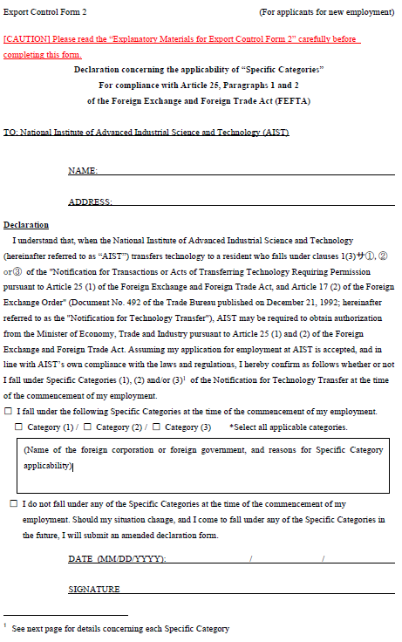
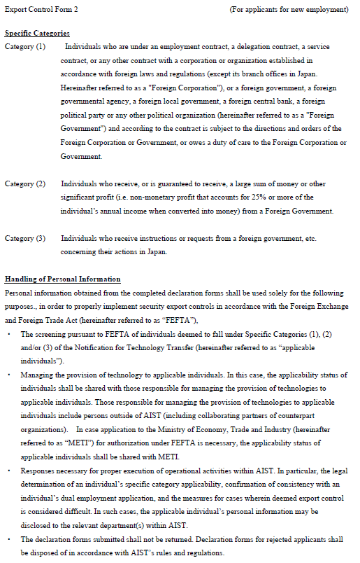
L: Research Plan for positions of “Outstanding Research Scientist”
(No more than 2 pages, including figures)
* Only applicable person. Delete this page, if not applicable.
Name:

Research theme:
Research Department which is related to your research theme:
Research Plan in AIST:
- Purpose of research, research background, creativity, novelty
- Research plan including research method
- Research budget Plan of JPY 40,000k, including equipment and facility you need

